Technical Appendix

Supplemental Methods
We excluded areas with slopes greater than 40% from the study due to researcher safety concerns and access issues. We selected slope categories to match those used in the regional fall biomass or RDM guidelines (Bartolome et al. 2006, 2). We initially derived field maps depicting slope classes in the office using 10-m Digital Elevation Model grids, then confirmed in the field using manual clinometers. We selected a subset of slope classes within each site depending on what was available within the accessible burn area. We then adjusted office-generated locations in the field to accommodate site conditions and safety concerns. Field fitting included targeting uniform vegetation while avoiding bare ground areas, rock outcrops, wetlands, tree cover, or disturbed areas (e.g., roads, firelines, or infrastructure), as well as ensuring visibility from safe vantage points during the burn operation. With one exception, all sites had at least 16 ft (5 m) of space between blocks to avoid “slop over” (unintended fire movement) between treatments or blocks.
Once the block locations were finalized, we placed t-posts in the four corners of the 33-by-21-ft (10-by-6.5-m) blocks, with two additional t-posts at midpoints (16 ft [5 m]) along the long sides of the block (see figure 2). We oriented all blocks to have the 21-foot (6.5-meter) sides at the bottom and top of a slope, if present. Where possible, we aligned the block with the anticipated wind direction where the wind would push the fire up the length of the treatments and reduce slop over potential. We marked t-posts with high visibility tape at 1-ft (0.3-m) intervals to improve field and digital reading of flame height for all sites (except the first two).
We laid out four linear biomass treatments within each block, with each treatment separated by 1.6 ft (0.5 m) of bare mineral soil to reduce slop over between treatments. The outer perimeter of the blocks also included 1.6 ft (0.5 m) of bare mineral soil to isolate the treatments. We clipped the biomass in the linear treatments with string trimmers and raked to reflect three grazing intensities: light (1,000 to 1,500 lb/acre), moderate (500 to 1,000 lb/acre), and heavy (0 to 500 lb/acre). An additional linear strip was untreated and represented ungrazed or very lightly grazed (>1,500 lb/acre) conditions. We placed treatments in the same order for each block. We clipped biomass from one representative sample of each treatment level of each block using standardized quadrats and weighed the sample in the field. We then dried these samples in a controlled environment and reweighed them to assess minimum dry weight.
We adjusted the grazing intensity levels selected for this study from Bartolome et al. 1980 and 2006; the former study used treatment levels of 0, 250, 500, 750, and 1,000 lb/acre and the latter provided minimum RDM recommendations ranging from 300 to 2,100 lb/acre. We limited the treatment levels for this study to three treatments and an unmanipulated control to balance the desire for replication within and between sites, number of manipulated treatments, and operational ability to implement replicates within an active prescribed burn.
We installed three aluminum metal tags painted with temperature-sensitive paints (Tempilaq) within each treatment strip to estimate maximum surface soil temperature reached during the burn. We painted each metal tag with five to seven strips of thermal paints that degrade at specific temperatures, ranging from 225 to 650 °F (107 to 343 °C; Iverson et al. 2004). We placed the tags at the 8-foot (2.5-m), 16-foot (5-m) (halfway), and 25-foot (7.5-m) marks along the midline of each treatment. We placed each tag on bare soil and covered it with vegetation to match the typical conditions within each treatment. We examined the metal tags after the burn to identify the number of paint strips that had identifiable chemical alteration. Visible alteration of a given paint strip indicates that the associated temperature threshold was exceeded by the fire at the soil surface. Surface temperature data exclude areas where the fire did not reach and where the fire did not meet a minimum temperature of 225 °F (107 °C), the lowest temperature threshold of the painted strips.
Before and after each burn, we conducted point intercept transects along the midline of each 33-foot (10-m) treatment, recording the top hit encountered every 4 in (10 cm) for a total of 100 points per transect, to assess the cover of general vegetation classes: live grass, burned grass, live forb, burned forb, unburned thatch, burned thatch, bare ground, rock (⅓ in or >8 mm), white ash, and black ash. If any part of the intercepted plant or litter was burned, we considered the point burned. We described burned vegetation as “ash” if the structure of the burned vegetation was no longer recognizable and generally disintegrated if touched.
We ignited treatments by a drip torch along the same side of each block. In some instances, we ignited treatments rapidly and sequentially, while in others we burned treatments at staggered intervals to avoid unintended movement of fire between treatments. Where possible, we selected for head fire characteristics (moving from the bottom to the top of the hill and/or with the wind) to better match prescribed fire behavior to what might be experienced on a wildfire, although variable wind conditions were common.
We conducted some burns as part of a larger burn unit while we burned others specifically for this study. Due to the challenge of executing these relatively small blocks in a dynamic fire setting, some data were lost due to slop over from one treatment into another. These were relatively infrequent events: four occurred into 0 to 500 lb/acre treatments, two into 1,000 to 1,500 lb/acre treatments, and one into the >1,500 lb/acre treatment. In these cases, we excluded rate of spread and cover data for the affected treatments from the analysis, but we kept the flame height and surface temperature results in the analysis. The flame heights within the treatment represent the potential of that biomass to produce a given flame height. Similarly, the surface temperature results reflect the ability of the associated biomass to generate a given amount of heat from fire at the ground level. Neither of these data should be affected from slop over since both reflect the capacity of the biomass within the treatment to affect fire behavior.
We used the midpoint when a flame was recorded as being in a range (e.g., 3.5 when 3 to 4 ft was recorded). We recorded a binary zero or one to identify if a treatment had the fire line cross the 33-foot (10-m) mark, which marked the edge of the treatment.

Variables Analyzed
We analyzed fire behavior variables including proxies for fire intensity, average rate of spread, maximum flame height, and whether the fire passed 33 ft (10 m). Dry herbaceous biomass weight from each treatment was the primary independent variable analyzed. We included additional independent variables: vegetation zone (CALVEG zone) (USDA 2011), grassland type (Bartolome et al. 2006), year, season, slope, and weather parameters (ambient temperature, relative humidity, average wind speed, and maximum windspeed).
Fire intensity metrics assessed included soil surface temperature, total residual white ash, and total burned percent cover. Total white ash is an indicator of high severity fire while black ash is an indicator of moderate severity (Parson et al. 2010, 49). Total burned cover included all white and black ash and burned vegetation. Data reported on percent of cover burned reflects the patchiness of a burn.
Average rate of spread was the time the flaming front took to move from 0 to 33 ft (0 to 10 m). We excluded treatments where the flaming front stopped before it reached 33 ft from the rate of spread analysis. Maximum flame height was the greatest height of flame recorded along each treatment. We also generated a binary variable, flame height above or below 4 ft (1.2 m), to relate directly to firefighting strategies. If wildfire flames are greater than 4 ft (1.2 m), firefighting efforts shift from hand crew to heavy equipment containment for firefighter safety (Andrews et al. 2011, 1).
We analyzed biomass as a continuous variable even though it was initially associated with categorical treatment classes because the final dry weight did not necessarily correspond to the intended treatment level and the continuous data provided more detailed thresholds for management.

Data Analysis
We developed conditional inference trees which estimate regression relationships between each parameter using binary recursive partitioning within a conditional inference framework. The process first tests independence between independent variables and the dependent variable. If variables are not independent, the algorithm stops. If variables are independent, the algorithm identifies the parameter with the strongest association with the response variable and creates a p-value for the relationship of the single variable and response. The tree splits at the selected value producing a binary decision point partitioning the data. This process is repeated for all remaining variables.
In addition to the two variables specifically targeted for management-focused outcomes (did flame lengths reach 10 ft and did fire stop by 33 ft), we ran conditional inference trees with the remaining variables (technical appendix figure 1). These variables were not considered critical to fire management.

Interpretation of Non-Management Focused Conditional Inference Trees
The conditional inference trees for non-critical fire behavior were produced to provide additional information for readers interested in the full range of outcomes based on the available data. The outcome for flame height only split at biomass as a variable (technical appendix figure 1A), indicating that flame heights were generally below 4 feet where biomass was below 1,171 lb/acre, which is similar to the threshold identified above in Figure 4A. Rate of spread (technical appendix figure 1B) had multiple nodes with different variables, dividing the data into overlapping ranges of rate of spread. The maximum temperature outcome also had multiple nodes for different variables, with season, slope class, and biomass nodes (technical appendix figure 1C). Notably, a group of 12 treatments occurring in summer on 0-10% slopes had relatively higher temperatures. Also, the node at 1,469 lb/acre biomass for summer burns with 10 to 40% slopes indicates that treatments with lower biomass had surface temperatures lower than 500 degrees F while those with higher biomass had temperatures over 500 degrees F. Examining the conditional inference tree for proportion burned shows a single node of biomass at 835 lb/acre, where biomass above this threshold has a higher proportion burned, similar to the relationship shown in figure 3D. Lastly, the conditional inference tree for proportion of white ash has an initial node between burn types, then biomass at 2,400 lb/acre. Within backing and head fires as a group, treatments with biomass levels lower than the threshold had much lower proportions of white ash (near zero), while there was much more variability in proportion of white ash above the threshold.
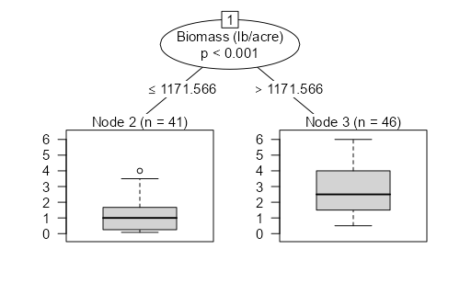
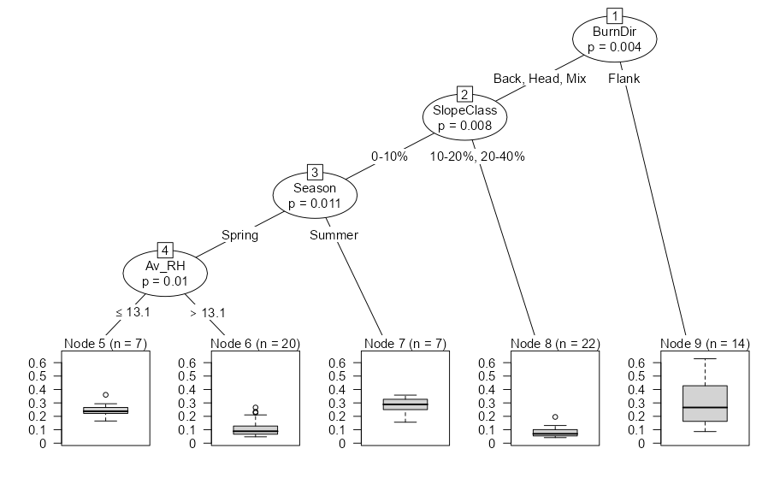
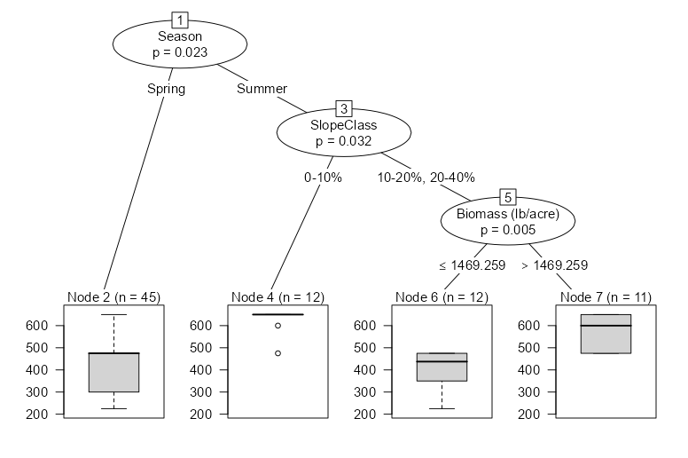
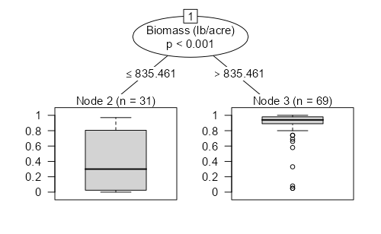
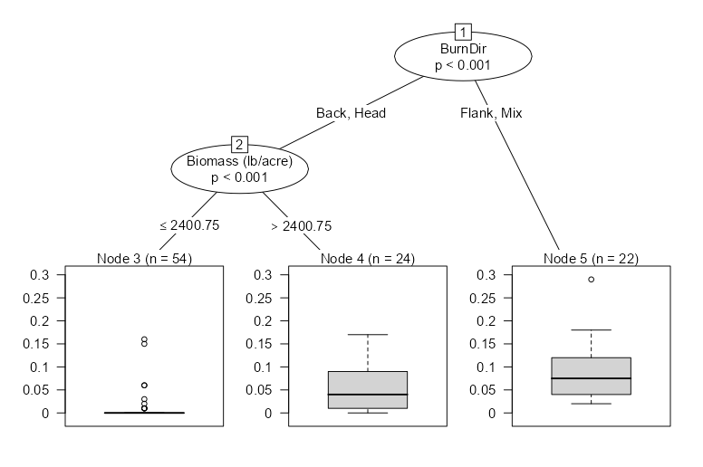
Technical Appendix Figure 1. Conditional inference trees for additional fire behavior metrics from herbaceous biomass treatments within prescribed burn study sites across California, USA (2020 to 2022). Fire behavior metrics include flame height (A), rate of spread (B), maximum surface temperature of burn (C), total biomass consumed (D), and proportion white ash (E).
Proportion White Ash
Proportion Burned
Surface Temp. (F)
Rate of Spread (m/s)
Flame Height (ft)
A
B
C
D
E

References
Andrews PL, Heinsch FA, Schelvan L. 2011. How to generate and interpret fire characteristics charts for surface and crown fire behavior. RMRSGTR-253. U.S. Department of Agriculture, Forest Service. 48 p. www.fs.usda.gov/rm/pubs/rmrs_gtr253.pdf (accessed Mar. 10, 2024).

Bartolome JW, Frost W, McDougald N. 2006. Guidelines for residual dry matter (RDM) management. UC Agriculture and Natural Resources Publication 8092. 6 p. https://doi.org/10.3733/ucanr.8092

Bartolome JW, Stroud MC, Heady HF. 1980. Influence of natural mulch on forage production at differing California annual range sites. J Range Manag 33(1):4–8. https://doi.org/10.2307/3898219

Hothorn T, Hornik K, Zeileis A. 2006. Unbiased recursive partitioning: A conditional inference framework. J Comput Graph Stat 15(3):651–74. https://doi.org/10.1198/106186006X133933

Hothorn T, Zeileis A. 2015. partykit: A modular toolkit for recursive partytioning in R. J Mach Learn 16(118):3905–9. https://jmlr.org/papers/v16/hothorn15a.html

Kruskall WH, Wallis WA. 1952. Use of ranks in one-criterion variance analysis. J Am Stat Assoc 47(260):583–621. https://doi.org/10.2307/2280779

Launchbaugh K, Walker J (eds.). 2006. Targeted Grazing: A Natural Approach to Vegetation Management and Landscape Enhancement. American Sheep Industry Association. 207 p. www.lib.uidaho.edu/digital/rangecoll/items/rangecoll59.html (accessed Mar. 10, 2024).

Parson A, Robichaud PR, Lewis SA, Napper C, Clark JT. 2010. Field guide for mapping post-fire soil burn severity. General Technical Report RMRS-GTR-243. U.S. Department of Agriculture, Forest Service. www.fs.usda.gov/rm/pubs/rmrs_gtr243.pdf (accessed Mar. 10, 2024).

Ratcliff F, Barry S, Rao D, et al. 2023. Cattle grazing moderates greenhouse gas and particulate matter emissions from California grassland wildfires. Sustainability 15(18):13539. https://doi.org/10.3390/su151813539

[USDA] United States Department of Agriculture Forest Service. 2011. CALVEG Tiles Ecoregions. FSGeodata Clearinghouse Enterprise Data. https://data.fs.usda.gov/geodata/edw/datasets.php (accessed Mar. 10, 2024).

Zeileis A, Hothorn T, Hornik K. 2008. Model-based recursive partitioning. J Comput Graph Stat 17(2): 492–514. https://doi.org/10.1198/106186008X319331

