Technical Appendix – New estimates show the first decline in California’s organic share of cropland
This technical appendix describes the assumptions we relied on to estimate organic cropland and animal production site acreages for California and describes the details of our decisions about how to group commodity categories and calculate production site acreages from anonymized CCOF data.

1) Validations
Our analysis relies on two assumptions: that the CCOF data are largely representative of the statewide population of certified and exempt organic producers required to register with SOP in terms of 1) the proportion of acres used for cropland and animal production, and 2) the geographic distribution by county. To test each of these assumptions, we conducted two validation checks comparing available CCOF and SOP data by 1) commodity categories and 2) county. First, to validate that CCOF data were roughly representational of organic SOP registrants in terms of commodity categories, we compared the share of organic harvested acres by commodity category each year as reported by CCOF and SOP, grouping the categories as needed to align the two sources (see Section 2.1 of this appendix for more details on how these groupings were done). The rates were quite similar — none differed by more than 5 percentage points. Second, to validate that CCOF data were roughly representational of organic SOP registrants in terms of geographic location, we compared the share of statewide organic production acres located in each county as reported by CCOF and SOP. These rates were also quite similar; in 2022, rates were only different by more than 5 percentage points in Kern and Modoc counties. For these two counties, we conducted further comparison of the CCOF and SOP shares of organic harvested acres by commodity category (mirroring the method in our first validation check). This county-level commodity category validation indicated that CCOF category were representational of the SOP population in Modoc County, but results were unclear for Kern County because of redacted acreage data from SOP. As a result, we used county-level CCOF category proportions to estimate organic cropland and animal production acreages for Modoc County in Method 1 of our final analysis, but statewide CCOF category proportions for the respective Kern County estimates.

1.1) Commodity category validation
To test our assumption that the commodities present in CCOF data are representational of the overall organic SOP registrant population, we compared the share of organic harvested acreage used for 1) animal production and field crops, 2) cropland, excluding field crops, and 3) fallow and all other land use as reported by CCOF and SOP for all years available (2019 through 2022; 2018 SOP data does not include statewide data for harvested acres by commodity type). These commodity groups were chosen based on commodity details available in both datasets; details on how individual commodities were grouped for each data source are available in Section 2.1 of this appendix (see Table A).

Figure A shows the difference between the proportion of CCOF total crop acres in each commodity category each year and the proportion of SOP total harvested acres in each category each year (Equation A). The differences in rates are quite small; the largest variation is 5 percentage points (.0501) for the animal production and field crops category in 2019. This suggests good alignment between statewide CCOF data and SOP registrants of the distribution across commodity categories, and it validates our assumption that CCOF data is representational of statewide organic producers. We therefore moved forward with using the CCOF rates to estimate the statewide production site acreage by large commodity category from SOP totals (see Method 1 of our corresponding manuscript).

Equation A.
$${Difference}_{Categtory,year}= \frac{{Sum}_{Category, Year}\left(CCOFCropAcres\right)}{{Sum}_{Year}\left(CCOFCropAcres\right)}- \frac{{Sum}_{Category, Year}\left(SOPHarvestedAcres\right)}{{Sum}_{Year}\left(SOPHarvestedAcres\right)}$$

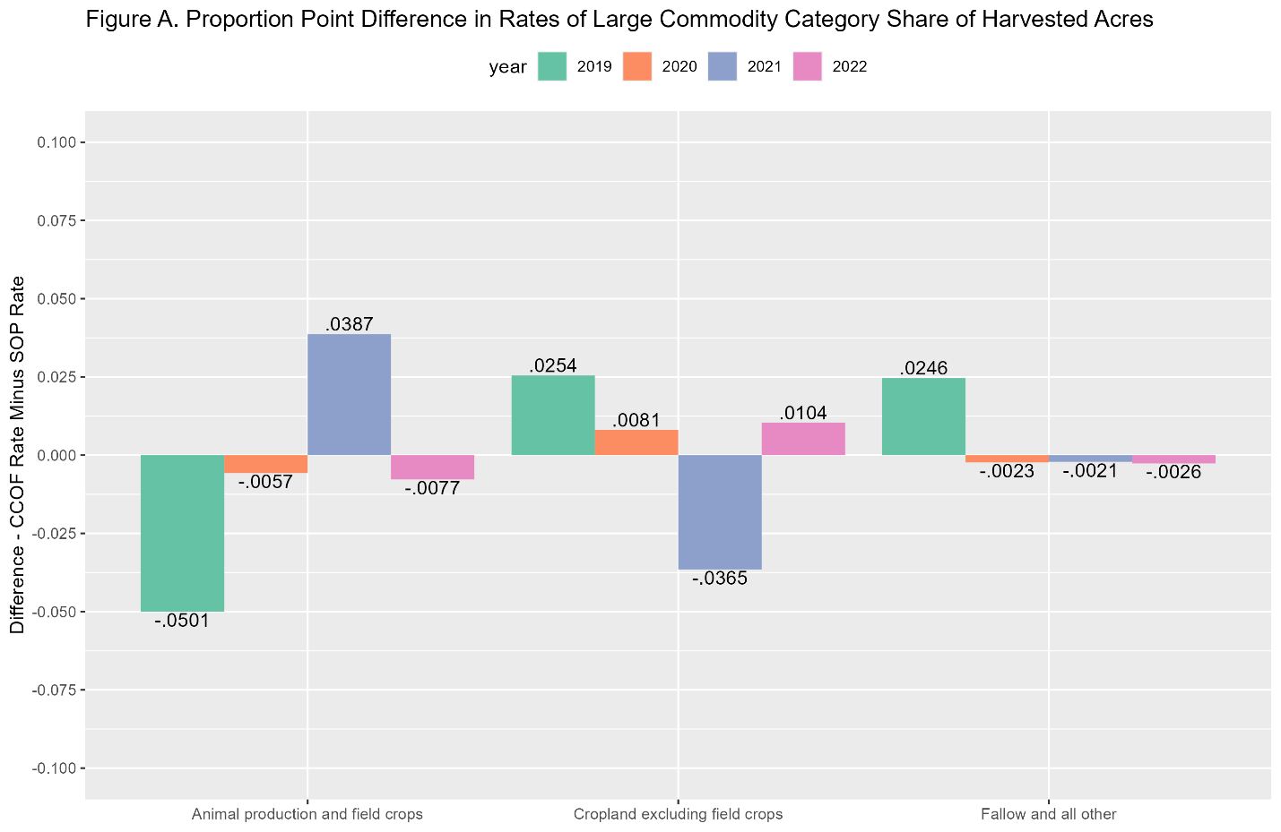

1.2) Geographic distribution validation
To test our assumption that CCOF data are geographically representative of SOP registrants overall, we explored the differences between the proportion of statewide parcel acres (from CCOF) and the proportion of statewide production site acres (from SOP) in each county (Equation B). Because we were interested in estimating county-level organic production site acreage for the year 2022 using the SOP data available directly from CDFA, we focused on the county rate differences for the years that SOP data were available directly from CDFA: 2018 through 2022. Most counties had good alignment between their rates of statewide organic acres between CCOF and SOP; differences in these rates for all but two counties (Kern and Modoc) were less than 5 percentage points for all years after 2017. Differences in rates for Kern and Modoc counties are shown in Figure B; CCOF data seems to over-count Kern organic acres and under-count Modoc organic acres as compared to SOP. This analysis suggests that the geographic distribution of CCOF is representational of overall SOP registrants except for those in Kern and Modoc counties.

Equation B.
$${Difference}_{County,year}=\frac{{Sum}_{County, Year}(CCOFParcelAcres)}{{Sum}_{Year}(CCOFParcelAcres)}- \frac{{Sum}_{County, Year}(SOPProductionSiteAcres)}{{Sum}_{Year}(SOPProductionSiteAcres)}$$

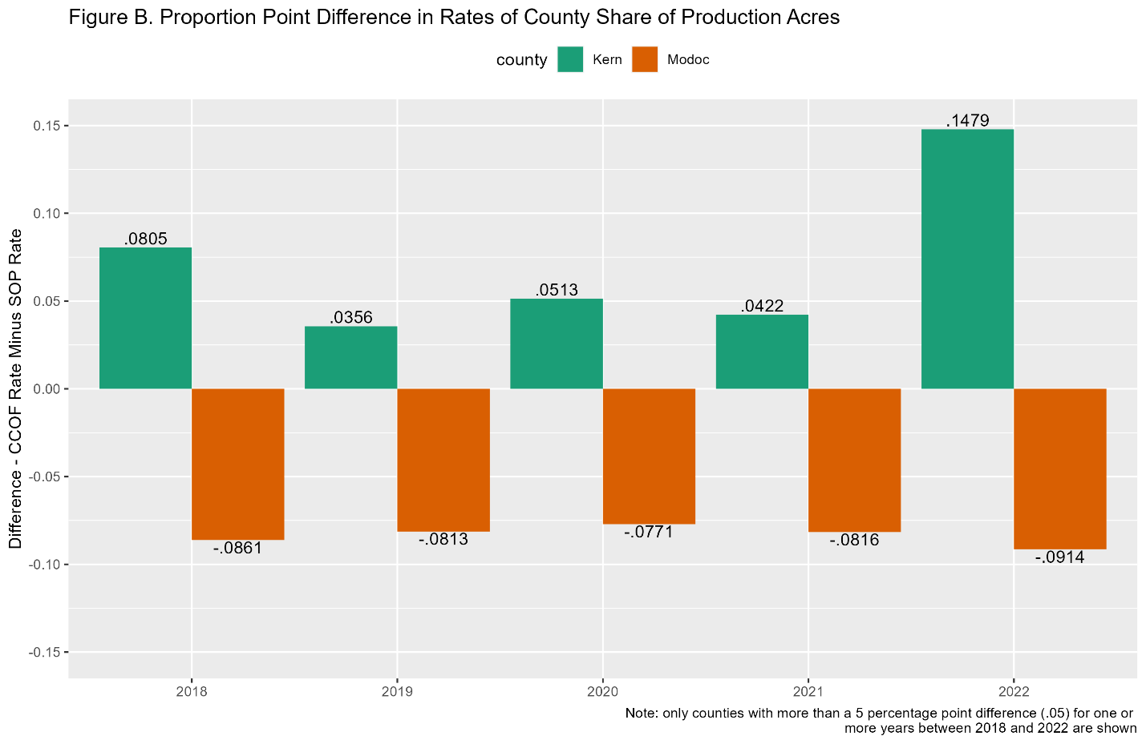

Next, we explored the commodity category representation of CCOF data, repeating the validation in section 1.2 on this technical appendix, within Kern and Modoc counties. Figure C shows the difference between the proportion of CCOF total crop acres in each commodity category and the proportion of SOP total harvested acres in each category in Kern and Modoc in 2022 (Equation C). Because the differences in rates were quite small for Modoc County, less than 5 percentage points (.0349 and -.0013), we chose to use county-level CCOF data to estimate the split between cropland and animal production acres in this county in Method 1 of our manuscript. However, in Kern County, the rate of organic harvested acres used for animal production and field crops was much higher in the CCOF data (92.68%) than was reported by SOP (2.48%). While this likely results from SOP redacting 2022 harvested acreage data for beef cattle production for Kern County, we were unable to confirm the representativeness of CCOF data for this county. As a result, we used statewide CCOF rates of cropland and animal production acres in place of county-level ones for Kern County in Method 1 of our manuscript.

Equation C.
$${Difference}_{Categtory,County}= \frac{{Sum}_{Category, County}(CCOFCropAcres)}{{Sum}_{County}(CCOFCropAcres)}- \frac{{Sum}_{Category, County}(SOPHarvestedAcres)}{{Sum}_{County}(SOPHarvestedAcres)}$$

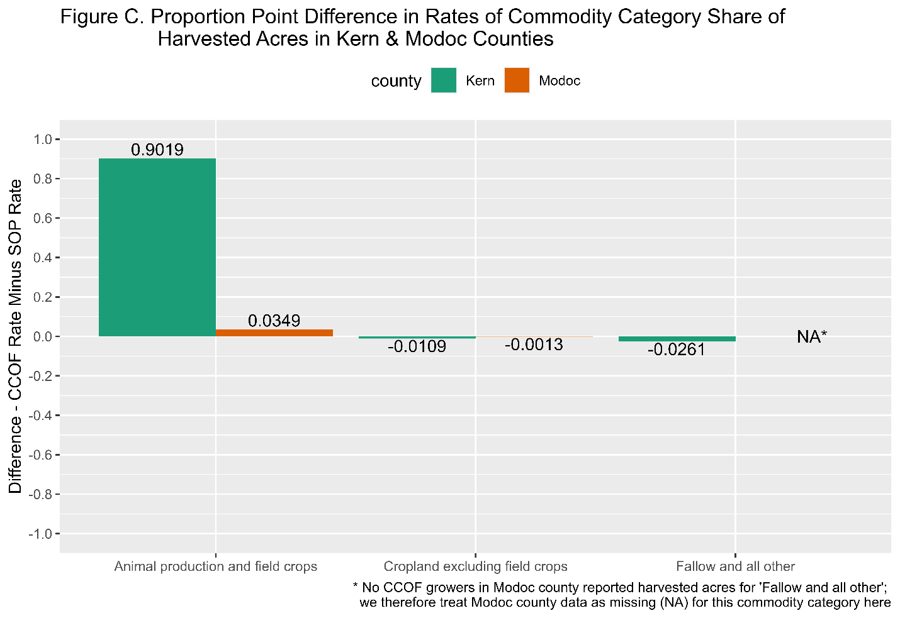

2) Other Technical Decisions

2.1) Commodity category grouping decisions
The overarching goal of the commodity category grouping was to separate cropland from land used for animal production since these represent distinct types of farming that should be, and are, considered differently in goals around organic share of agricultural production. We also included a separate category for fallow land and other agricultural production for which we did not have enough information to classify as cropland or animal production. Table A in this section documents how commodity category groupings were constructed from SOP and CCOF, both for the analyses presented in our manuscript and for the validations documented above in this appendix.

Because SOP data groups field crops with pasture and rangeland in “All Other Field Crops (Incl. Pasture and Rangeland),” we grouped field crops with animal production when validating the representativeness of CCOF data in terms of commodity category distribution. This grouping is presented as “Animal production and field crops” in Figure A and Figure C above.

While some cannabis production was included in the CCOF data (only a handful of parcels), we excluded it from analysis because the organic certification for Cannabis (Ocal) is separate from the State Organic Program and Cannabis is not included in the National Organic Program certification process.

Table A. Grouping of Commodity Categories
Manuscript Grouping | CCOF Commodity Categories |  |  | Validation Grouping | SOP Commodity Categories
Cropland | Fruit | Grapes | Juice; Raisin; Table; Wine; Other | Cropland excl. field crops | Almonds; Broccoli; Carrots; Celery/Celeriac; Citrus; Grapes Dried, Raisins; Grapes, Table; Grapes, Wine; Lettuce (Head, Leaf, Spring/Salad Mixes); Pome Fruit; Propagation; Spinach (Fresh and Processed); Stone Fruit; Strawberries (Fresh Market); Tomatoes; All Other Berries; All Other Fruit Crops; All Other Nut Crops; All Other Vegetables
Cropland | Fruit | Pome Fruit | Apple; Pear; Other | Cropland excl. field crops
Cropland | Fruit | Stone Fruit | Apricots; Cherries; Nectaries; Peach; Prunes; Other | Cropland excl. field crops
Cropland | Fruit | Subtropical Fruit | Avocados; Dates; Figs; Kiwi; Other | Cropland excl. field crops
Cropland | Fruit | Berries; Citrus; Other |  | Cropland excl. field crops
Cropland | Nuts | Almonds; Pistachios; Walnuts; Other |  | Cropland excl. field crops
Cropland | Other Crops & Land | Curry Trees; Leaves; Moringa; Nursery & Flower |  | Cropland excl. field crops
Cropland | Vegetables | Assorted Vegetables | Beans (Fresh); Garlic; Lettuces; Mixed Vegetables; Onions; Peas; Potatoes; Sweet Potatoes | Cropland excl. field crops
Cropland | Vegetables | Tomatoes | Fresh; Processing | Cropland excl. field crops
Cropland | Vegetables | Umbels & Herbs | Carrots; Herbs | Cropland excl. field crops
Cropland | Vegetables | Brassicas; Herbs; Other |  | Cropland excl. field crops
Cropland | Wild Crop | Blackberries; Flowers; Mushrooms |  | Cropland excl. field crops
Cropland | Field & Seed Crops | Grain & Forage | Alfalfa; Barley; Corn (Dry); Oats; Rice; Wheat; Other | Animal production & field crops | Cattle, Beef; Chicken, Broilers; Chicken, Layers; Fluid Milk, Cow; Seed Crops; All Other Dairy and Dairy Products; All Other Field Crops (Incl. Pasture and Rangeland); All Other Poultry/Livestock and Products
Cropland | Field & Seed Crops | Legumes | Beans (Dry); Other | Animal production & field crops
Cropland | Field & Seed Crops | Corn (Pop); Cotton; Fiber; Oil Crops; Other |  | Animal production & field crops
Animal Production | Field & Seed Crops | Pasture & Field | Native Grass Pasture; Pasture; Pasture & Rangeland; Rangeland | Animal production & field crops
Animal Production | Livestock Production Area |  |  | Animal production & field crops
Animal Production | Other Crops & Land | Snails (Wild Harvest) |  | Animal production & field crops
Fallow & Other | Field & Seed Crops | Pasture & Field | Woodlot | Fallow & Other | Fallow; All other not previously reported or listed
Fallow & Other | Other Crops & Land | Fallow |  | Fallow & Other | Fallow; All other not previously reported or listed
Fallow & Other | Wild Crop | Fallow |  | Fallow & Other | Fallow; All other not previously reported or listed

2.2) Land use allocation decisions
This section describes our process for calculating production site acreage totals by commodity category (cropland, animal production, and other land use) from available CCOF data, both at the statewide and county levels, using both parcel acre and crop acre information available in the CCOF data. We referenced crop acre information, which included details of how many acres in each parcel were used for a specific purpose each year, to establish how many acres within each parcel were primarily used for cropland, animal production, or some other purpose (including fallow). Each acre was only counted once; our decisions about how to treat overlapping land uses, outlined below, mirror instructions for the 2022 NASS Census of Agriculture (NASS 2022). For each CCOF parcel, the sum of a) cropland production site acreage, b) animal production site acreage, and c) fallow and other production site acreage equaled d) the reported parcel acreage (a + b + c = d).

How overlapping land uses were addressed:
- If the same acreage was reported as multiple cropland commodities (see Table A for details on which commodities we classified as cropland for our manuscript analysis), the acreage is only counted once as cropland.
- If the same acreage was reported as multiple animal production commodities (see Table A for details on which commodities we classified as cropland for our manuscript analysis), the acreage is only counted once as animal production.
- If the same acreage was reported as cropland and animal production commodities, the acreage is only counted once and is counted as cropland.
- Any parcel acreage not used for production in a year was counted as fallow and other for that year.

2.3) NASS categories included in total production site acreage
We used specific NASS agriculture categories for production site acreages based on the definitions of land use from the 2022 Census of Agriculture report form guide (NASS 2022). We used the sum of “Harvested cropland” and “Other cropland” for total cropland production site acreage, and the sum of “Permanent pasture and rangeland” and “Other pasture and grazing land” for total animal production site acreage. To avoid under-estimating organic shares of agricultural production land (by overestimating total agricultural production site acres), we excluded categories that suggested irregular production uses, like woodland or land used for homes, buildings, or roads. Restricting our use of NASS data to these specific categories had a small but noticeable effect on our organic share estimates (Method 2); estimates were 1-2 percentage points higher than when using all applicable land categories available through NASS.

2.4) Aligning CCOF acreage totals with NASS and SOP
NASS and SOP use different methods for calculating commodity-specific acreages. NASS uses acreage calculations that count each agricultural acre only once per commodity category and county. However, SOP reports organic acreages by commodity type as harvested acreages, where acreages are counted each time a crop is harvested. For example, the same 2 acres of land used to grow two distinct crops of corn in the same year is counted as 4 acres in SOP commodity type harvested acreage totals but only as 2 acres in NASS commodity type acreage totals. Because CCOF data includes crop acreages, we were able to mirror SOP’s harvested acreage totals when performing our validations as described in section 1 of this appendix. Because CCOF data also includes production site acreages, we were able to mirror NASS’s production site acreage method (see Section 2.2 of this appendix for details) to calculate organic acreage rates by commodity category for the results presented in our paper. We then used SOP’s organic production site acreages totals by county (in which all acres are only counted once) in Method 1 to estimate total organic production site acreages by commodity category and year and/or county.

References
NASS. 2022. “Section 2. Land Use in 2022.” In 2022 Census of Agriculture: Report Form Guide. USDA National Agricultural Statistics Service. https://www.nass.usda.gov/AgCensus/Report_Form_and_Instructions/2022_Report_Form/2022_Census_of_Agriculture_Report_Form_Guide.pdf.
NASS. 2024. 2022 Census of Agriculture, California State and County Data. Part 5. Geographic Area Series. USDA National Agricultural Statistics Service. https://www.nass.usda.gov/Publications/AgCensus/2022/Full_Report/Volume_1,_Chapter_2_County_Level/California/cav1.pdf.

CCOF shared city information for their certified organic parcels; we obtained county indicators for each parcel by geocoding these data in ArcGIS Pro.
Land with buildings used for animal production was included in animal production because it was grouped with other animal production land uses in CCOF data; NASS includes this land as other (NASS 2024, 340).

