Supplementary Information Figures and Tables
Figure SI.1: Presents the 15 groundwater basins within the SJV divided into 49 subregions drawn to capture districts with similar historical surface water availability.
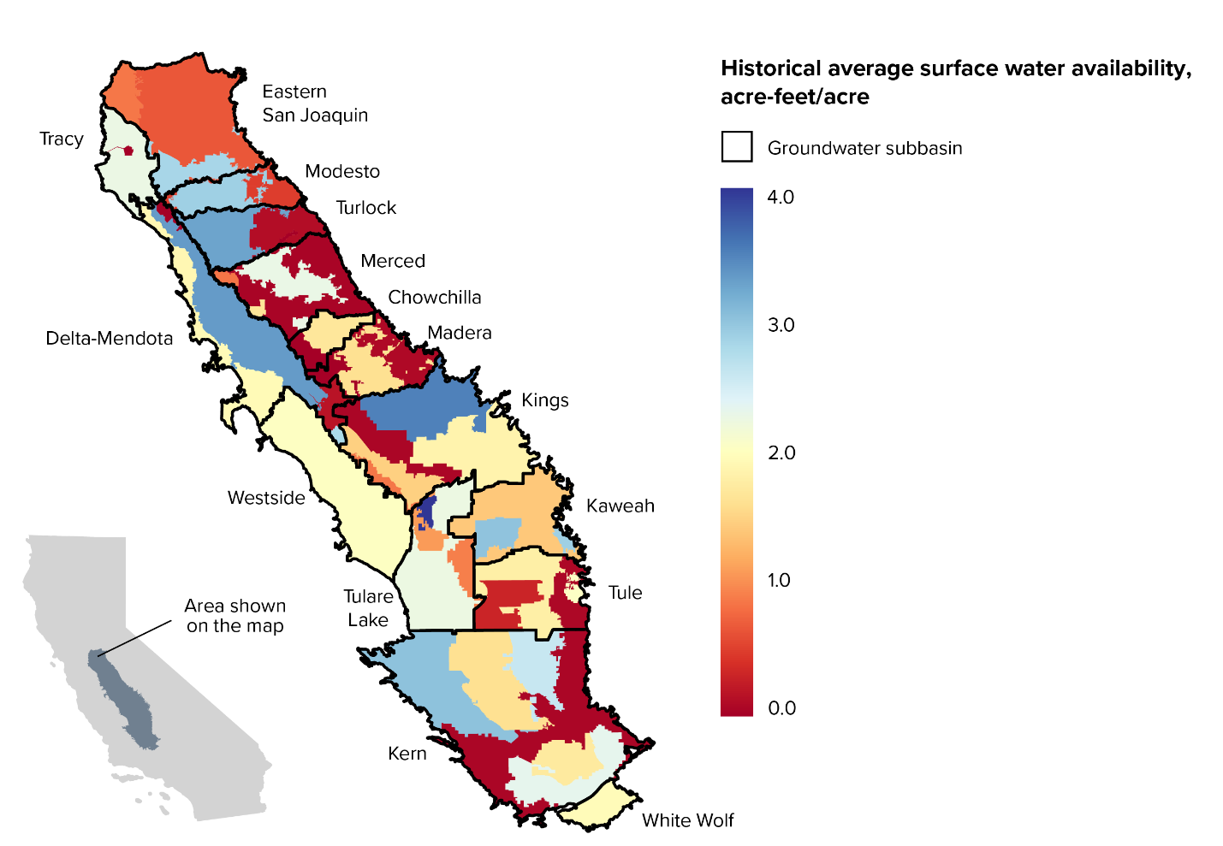

Figure SI.2: Agricultural production model diagram showing inputs, outputs, and data relationships to the independent farm size dataset.
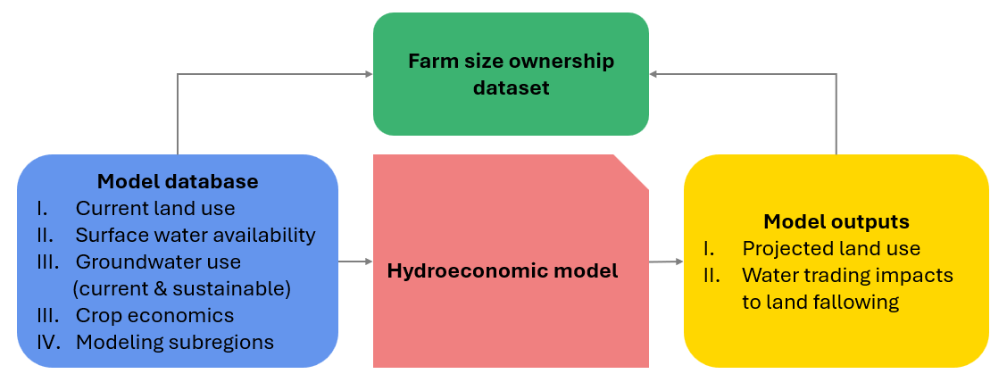

Table SI.1: Count of farms by size class and groundwater basin. Note that the farm count total here differs from the 34,577 presented in the main text due to farms spanning multiple basins.
Groundwater basin | Small | Medium | Large | TOTAL
Chowchilla | 281 | 121 | 108 | 510
Delta-Mendota | 1,790 | 734 | 392 | 2,916
Eastern San Joaquin | 5,550 | 870 | 213 | 6,633
Kaweah | 2,352 | 729 | 269 | 3,350
Kern | 942 | 763 | 588 | 2,293
Kings | 6,592 | 1,263 | 520 | 8,375
Madera | 783 | 290 | 206 | 1,279
Merced | 1,885 | 438 | 204 | 2,527
Modesto | 2,060 | 268 | 99 | 2,427
Tracy | 489 | 221 | 79 | 789
Tulare Lake | 662 | 270 | 158 | 1,090
Tule | 1,093 | 507 | 333 | 1,933
Turlock | 2,954 | 468 | 139 | 3,561
Westside | 230 | 357 | 363 | 950
WhiteWolf | 6 | 27 | 33 | 66
TOTAL | 27,669 | 7,326 | 3,704 | 38,699

Table SI.2: Acreage of farms by size class and groundwater basin.
Groundwater basin | Small | Medium | Large | TOTAL
Chowchilla | 7,595 | 23,040 | 82,232 | 112,867
Delta-Mendota | 48,918 | 129,951 | 244,767 | 423,635
Eastern San Joaquin | 107,953 | 150,611 | 121,554 | 380,118
Kaweah | 51,189 | 109,947 | 134,810 | 295,945
Kern | 27,985 | 137,464 | 533,582 | 699,031
Kings | 152,555 | 189,891 | 274,075 | 616,520
Madera | 21,917 | 43,487 | 122,294 | 187,698
Merced | 42,279 | 68,505 | 131,571 | 242,355
Modesto | 35,274 | 41,001 | 40,888 | 117,163
Tracy | 14,745 | 39,650 | 64,370 | 118,765
Tulare Lake | 16,453 | 43,418 | 206,239 | 266,110
Tule | 24,711 | 84,420 | 187,508 | 296,639
Turlock | 60,728 | 74,751 | 73,980 | 209,460
Westside | 7,271 | 73,393 | 293,980 | 374,645
White Wolf | 132 | 5,174 | 27,354 | 32,660
TOTAL | 619,705 | 1,214,703 | 2,539,203 | 4,373,611

Table SI.3: Count of farms by granular size bin and groundwater basin. Note that the farm count total here differs from the 34,577 presented in the main text due to farms spanning multiple basins.
Groundwater basin | 1-9 | 10-49 | 50-99 | 100-219 | 220-499 | 500-1999 | 2000+ | TOTAL
Chowchilla | 83 | 131 | 67 | 64 | 57 | 74 | 34 | 510
Delta-Mendota | 529 | 880 | 381 | 390 | 344 | 323 | 69 | 2,916
Eastern San Joaquin | 2,552 | 2,335 | 663 | 540 | 330 | 188 | 25 | 6,633
Kaweah | 960 | 963 | 429 | 418 | 311 | 230 | 39 | 3,350
Kern | 238 | 438 | 266 | 393 | 370 | 416 | 172 | 2,293
Kings | 1,908 | 3,629 | 1,055 | 759 | 504 | 392 | 128 | 8,375
Madera | 192 | 397 | 194 | 176 | 114 | 155 | 51 | 1,279
Merced | 557 | 1,064 | 264 | 239 | 199 | 165 | 39 | 2,527
Modesto | 1,079 | 759 | 222 | 157 | 111 | 88 | 11 | 2,427
Tracy | 153 | 210 | 126 | 128 | 93 | 64 | 15 | 789
Tulare Lake | 230 | 276 | 156 | 158 | 112 | 110 | 48 | 1,090
Tule | 435 | 429 | 229 | 257 | 250 | 252 | 81 | 1,933
Turlock | 1,189 | 1,422 | 343 | 293 | 175 | 114 | 25 | 3,561
Westside | 69 | 85 | 76 | 150 | 207 | 332 | 31 | 950
White Wolf | 3 | 2 | 1 | 14 | 13 | 19 | 14 | 66
TOTAL | 10,177 | 13,020 | 4,472 | 4,136 | 3,190 | 2,922 | 782 | 38,699

Tabel SI.4: Acreage of farms by granular size bin and groundwater basin.
Groundwater basin | 1-9 | 10-49 | 50-99 | 100-219 | 220-499 | 500-1999 | 2000+ | TOTAL
Chowchilla | 334 | 3,213 | 4,048 | 8,631 | 14,410 | 38,909 | 43,322 | 112,867
Delta-Mendota | 2,903 | 21,626 | 24,389 | 48,523 | 81,427 | 162,999 | 81,768 | 423,635
Eastern San Joaquin | 12,901 | 52,645 | 42,407 | 68,090 | 82,520 | 97,383 | 24,171 | 380,118
Kaweah | 4,277 | 22,277 | 24,634 | 44,553 | 65,393 | 110,152 | 24,659 | 295,945
Kern | 888 | 10,542 | 16,555 | 48,935 | 88,529 | 209,781 | 323,801 | 699,031
Kings | 8,192 | 80,544 | 63,818 | 83,907 | 105,983 | 149,211 | 124,863 | 616,520
Madera | 814 | 9,509 | 11,594 | 20,042 | 23,445 | 64,550 | 57,744 | 187,698
Merced | 2,842 | 23,716 | 15,720 | 27,278 | 41,227 | 82,438 | 49,133 | 242,355
Modesto | 4,654 | 17,362 | 13,258 | 17,363 | 23,639 | 32,966 | 7,922 | 117,163
Tracy | 712 | 5,740 | 8,294 | 16,205 | 23,446 | 38,619 | 25,750 | 118,765
Tulare Lake | 1,014 | 6,290 | 9,150 | 18,711 | 24,707 | 41,559 | 164,680 | 266,110
Tule | 2,209 | 9,516 | 12,986 | 29,125 | 55,295 | 108,918 | 78,590 | 296,639
Turlock | 5,910 | 33,310 | 21,508 | 35,498 | 39,253 | 48,734 | 25,246 | 209,460
Westside | 201 | 2,082 | 4,989 | 19,672 | 53,721 | 235,452 | 58,528 | 374,645
White Wolf | 19 | 40 | 74 | 1,798 | 3,376 | 6,359 | 20,995 | 32,660
TOTAL | 47,870 | 298,410 | 273,425 | 488,331 | 726,372 | 1,428,031 | 1,111,172 | 4,373,611

